ENTERPRISE INFRASTRUCTURE AND NETWORKS

IT 520

Lab #4

Dalal Alshahil

Due to: 03/18/2019

Include a terminal screenshot showing computer IP address on the front page.

**192.168.0.4**

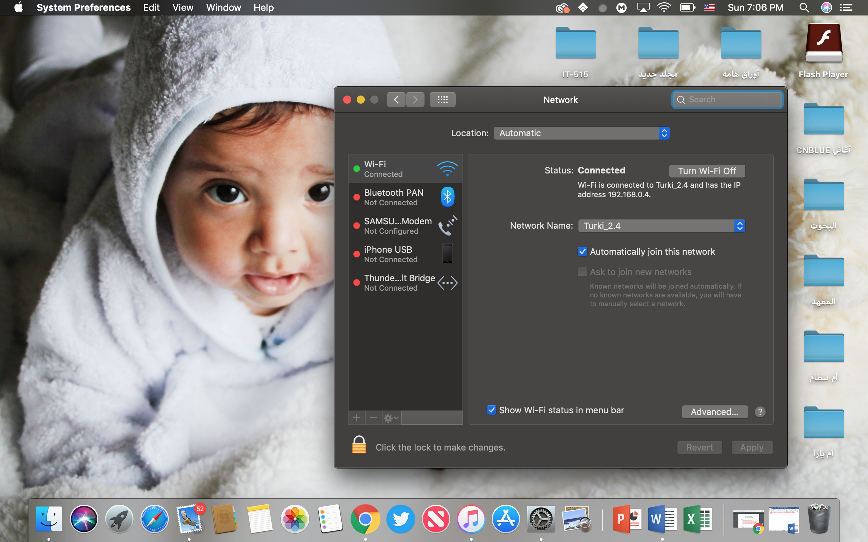

**Question #1:**

What is the IP address of your computer? – **Wireshark screenshot not, Terminal**

Solution: **192.168.0.4**

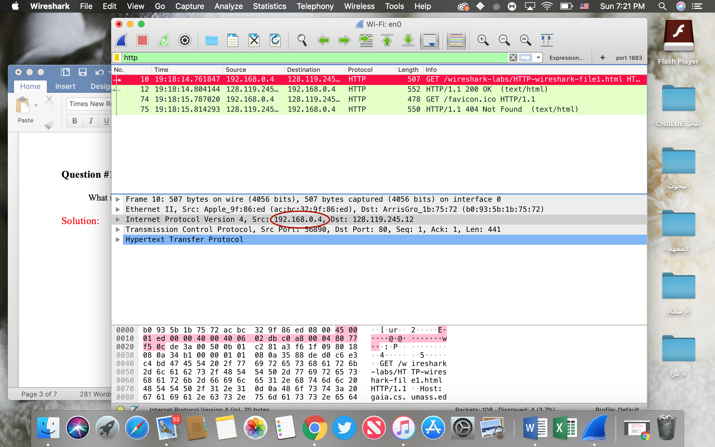

**Question #2:**

What is the total length of the datagram?

Solution: Total length: 493

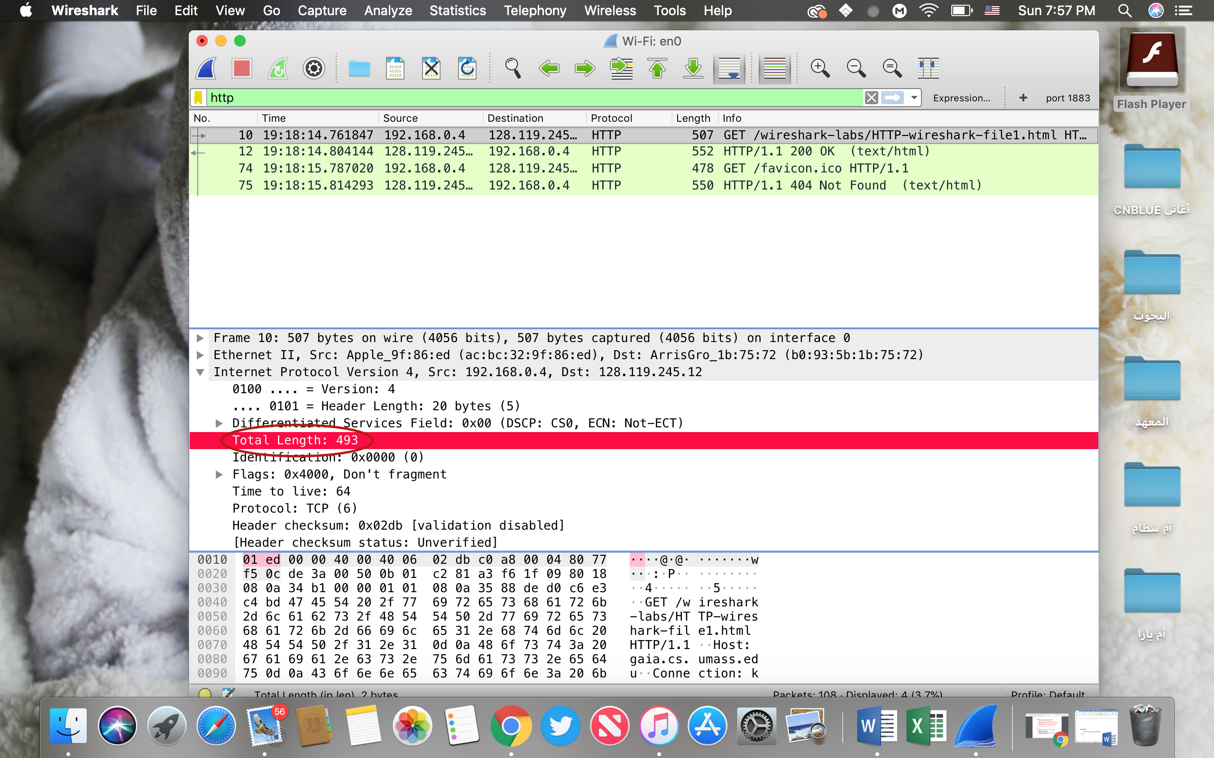

**Question #3:**

Has this IP datagram been fragmented?

Solution: No Fragment

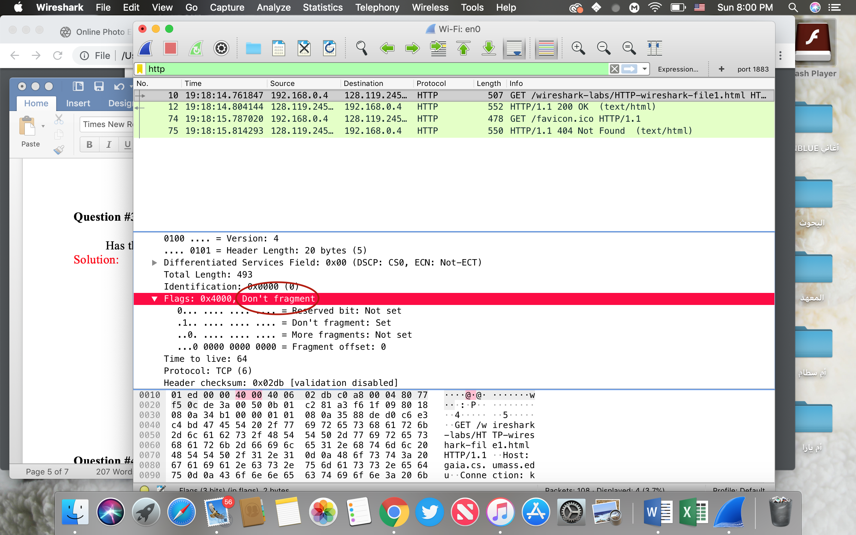

**Question #4:**

How many bytes are in the IP header?

Solution: 20 Bytes.

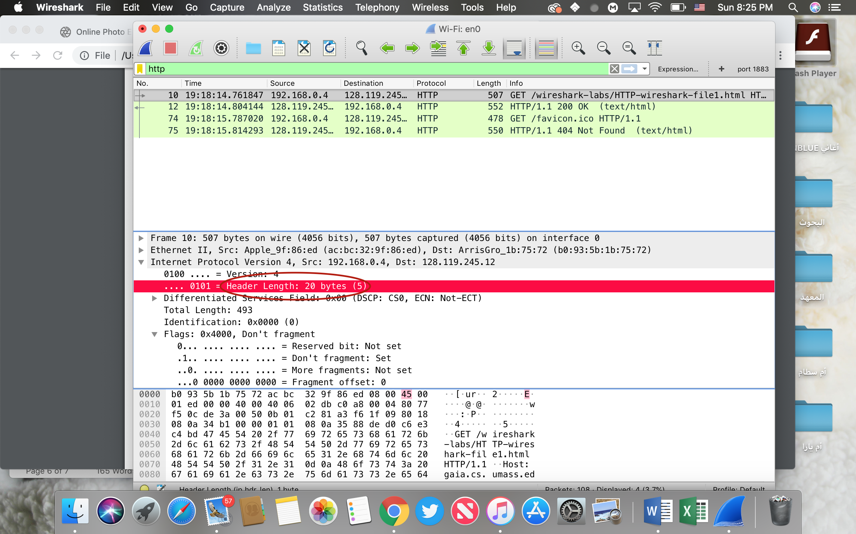

**Question #5:**

How many bytes are in the payload of the IP datagram? **Explain how you determined the number of payload bytes.**

Solution:

Since there are 20 bytes in the IP header.

493 bytes total length.

493-29 = 473 bytes in the payload of the IP datagram.